TV REMOTE OPERATED DOMESTIC APPLIANCES CONTROL

ABSTRACT
The project is designed to operate electrical loads using a TV remote. The remote transmits coded infrared data which is then received by a sensor interfaced to the control unit. The system operates electrical loads depending on the data transmitted from the TV remote. Operating conventional wall switches is difficult for elderly or physically handicapped people. This proposed system solves the problem by integrating house hold appliances to a control unit that can be operated by a TV remote.
RC5 based coded data sent from the TV remote is received by an IR receiver interfaced to the microcontroller of PIC family. The program on the microcontroller refers to the RC5 code to generate respective output based on the input data to operate a set of relays through a relay driver IC. The loads are interfaced to the control unit through the relays. The system can be used in existing domestic area for either operating the loads through conventional switches or with the TV remote.
The project can be enhanced by using radio frequency technology where the operational range shall be independent of line of sight distance as often encountered with IR type of remote control.
BLOCK DIAGRAM
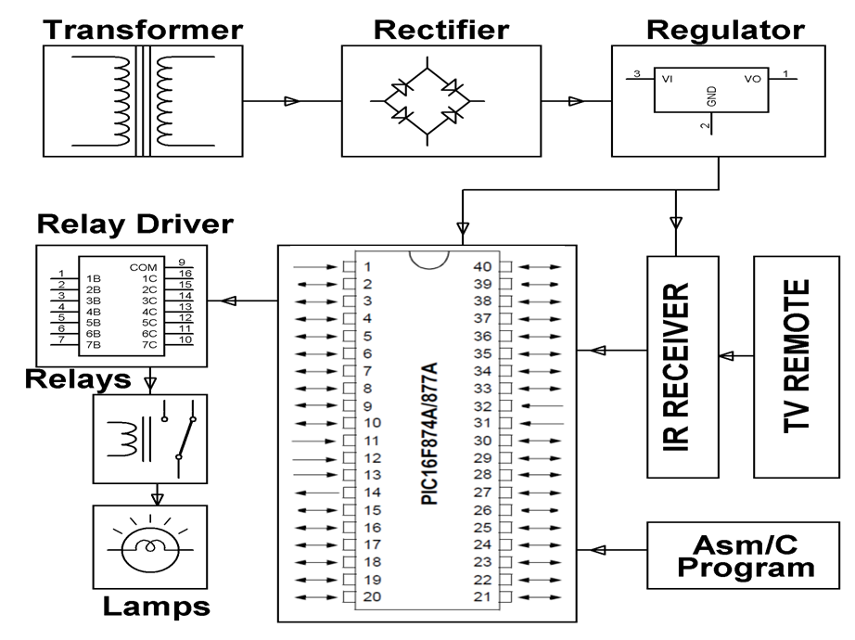
HARDWARE REQUIREMENTS:
PIC series Microcontroller, T.V Remote, IR sensor, Relays, Relay Driver IC, Crystal, Resistors, Capacitors, LED, Diodes, Transformer, Voltage Regulator, Lamps.

SOFTWARE REQUIREMENTS:
HI-TECH PICC Tool suite
Languages: Embedded C or Assembly

